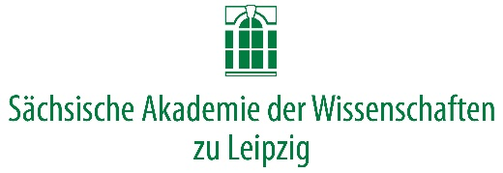

**Arabic Manuscripts and Collaboration in the Digital Environment**

Leipzig, September 4-5, 2019

This workshop will not be structured as a sequence of individual presentations. Rather, we have identified thematic clusters that will guide an open and flexible exchange.

Through such a conversation we want to locate and define possible areas and modes of cooperation as well as those questions on which further exchange is still necessary. The goal is not the presentation of publishable texts, but to start a continuous exchange, to build a like-minded network, and to learn from each other’s experiences.

September 4, 2019

9:30 Welcome

1. 10:00 – 12:00 Scope

In this session, we wish for every participating project to introduce itself, for which 15 minutes should generally suffice.

In particular, we would like you to present on the following points: What are the sources you are systematically collecting? What manuscript or archival collections are you working with? If you have a developed database, what type of data do you register (fields), and in which format? Who are your collaborators and what specific expertise do they bring to your efforts? An important aspect for any cooperation that might involve the exchange of information is the question of what rights you have to your data.

Additionally, if you have templates of your database fields to share so that participants could prepare their comments, we would distribute them beforehand.

12:00 – 13:00 Lunch

1. 13:00 – 15:00 Names and Entities: Modelling Data

Next, we would like to concentrate on ways to ensure that we are talking about the same thing when that same thing might be presented in quite different ways. What entities (people, places, institutions) should we distinguish by using persistent unique identifiers, gazetteers, or other existing repositories? What metadata do we collect on those entities? How do names work in different circumstances? And how should we represent possible or doubtful connections or identifications?

1. 15:30 – 17:30 Sustainability and Perspectives

What happens to your data and resources after the end of your funding? What strategies are available or in development to secure a continuous availability of your work for you and the field? What initiatives could we take as a cluster of projects with a common interest to further these developments?

At the end of this workshop, we want to review the previous discussion and determine what concrete initiatives could be or need to be taken in the future to initiate a cooperation among ourselves and possible other partners.

19:00 Dinner

September 5, 2019

1. 09:30 – open Individual Discussions

We want to give all participants the possibility to engage in bilateral discussions among themselves or with us about particular matters and open questions they deem important.